**DAILY ONLINE ACTIVITIES SUMMARY**

|  |  |  |  |  |  |  |  |  |
| --- | --- | --- | --- | --- | --- | --- | --- | --- |
| **Date:** | **13-7-2020** | | | | | **Name:** | **Poojashree T** | |
| **Sem & Sec** | **8th sem B sec** | | | | | **USN:** | **4al16cs064** | |
| **Online Test Summary** | | | | | | | | |
| **Subject** | | **No Test** | | | | | | |
| **Max. Marks** | |  | | **Score** | | |  | |
| **Certification Course Summary** | | | | | | | | |
| **Course** | **Machine Learning Foundation** | | | | | | | |
| **Certificate Provider** | | | **Great learning academy** | | **Duration** | | | **3.0hr** |
| **Coding Challenges** | | | | | | | | |
| **Problem Statement:** **1**. **to read the number and compute the series.**  **2. to count the number in th series.**  **3. to check whether number is palindrome or not.**  **4. to find the number between 0 and 50 which are not divisible by 2 and 3.**  **5.micro and array update**  Top of Form | | | | | | | | |
| **Status:completed** | | | | | | | | |
| **Uploaded the report in Github** | | | | | **yes** | | | |
| **If yes Repository name** | | | | | **Poojatgowda** | | | |
| **Uploaded the report in slack** | | | | | **yes** | | | |

**Online test**

No Test

**Certification course**

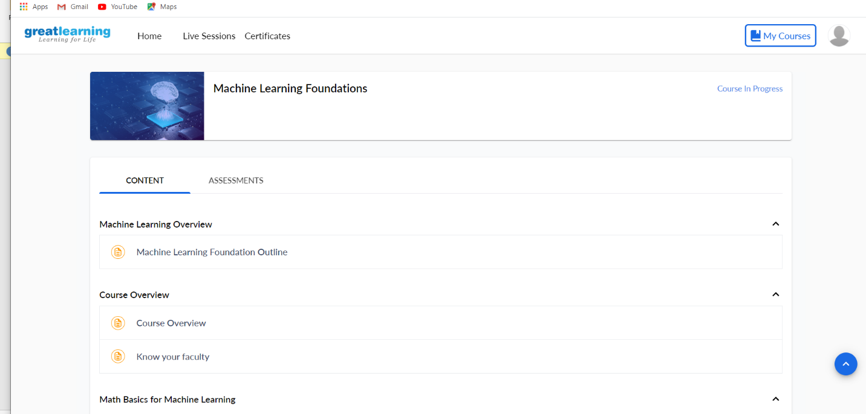

**Example: Program to find the sum of multiple numbers using Method Overloading**

public class JavaExample

{

int add(int num1, int num2)

{

return num1+num2;

}

int add(int num1, int num2, int num3)

{

return num1+num2+num3;

}

int add(int num1, int num2, int num3, int num4)

{

return num1+num2+num3+num4;

}

public static void main(String[] args)

{

JavaExample obj = new JavaExample();

//This will call the first add method

System.out.println("Sum of two numbers: "+obj.add(10, 20));

//This will call second add method

System.out.println("Sum of three numbers: "+obj.add(10, 20, 30));

//This will call third add method

System.out.println("Sum of four numbers: "+obj.add(1, 2, 3, 4));

}

}